Муниципальное бюджетное общеобразовательное учреждение «Средняя общеобразовательная школа с. Ездочное Чернянского района Белгородской области»

Моё Святое Белогорье
Памятник Святославу Храброму

Подготовила ученица 8 класса
Должикова Юлия
учитель Усенко Любовь Михайловна

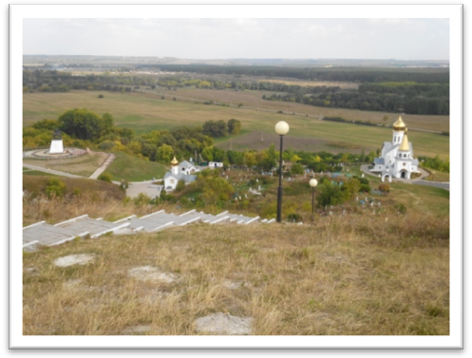
You are welcome to my native village Ezdochnoye. If we travel some kilometers long we found ourselves on the picturesque bank of the Oskol River. And here you can see the treasure of our region, of the whole country Svyato-Troitsky Male Monastery of Holki. It is the unique ecclesiastical center of the Belogoye (White Hills).
Please, pay your attention to the memorial of Svyatoslav the Brave, which is situated near the Monastery. He has returned to the places of his fighting youth after several thousand years. Probably it is the historical justice, that monuments should be on the territory, where military glory was born. Klykov, an architect, is one of the brightest representatives of our tribe, has only personified in the metal the fact always lives among our compatriots.
And today we can hear the words of perplexity, why this monument to warrior Svyatoslav, pagan’s prince, stands here, near Holki’s monastery, this sacred orthodox place. They say this detail interferes the people praying for Jesus Christ.
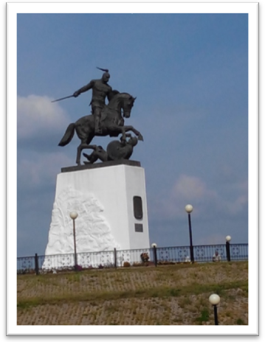
But it goes without saying that conception of Russian’s Orthodoxy impossible without name Svyatoslav.
It’s true, he is a pagan’s prince. But he was a person who respected people of different faiths. It was imported for him that they should be useful for the true deed.
And it is interested for us to find out, why Svyatoslav has returned namely to our Belgorod’s steppes. I think it is very exciting and instructive story.
So, let’ start.
About thousand years ago, so named, Gorodishchenskaya Rus’, was situated here. The capital of this land was town Golun’ or Gelon, as Gerodot called it. All people spoke here one and the same language. It was our motherland, on which time to time waves of nomad rolled. But they couldn’t conquer Slavs.
Gorodishchenskaya Rus’ itself was divided into several administrative regions. The center of the main region was in Kiev, the center of the northern land was in Pereyaslavl’ and the capitals of Khazariya was Itil’ and Sarkel.
It was a certain land. But with the rise of Christianity, and then Islam, Gorodishchenskaya Rus’ began to lose its unity. The period of wars had began. In 940, hazaro-iyudeiskoye yoke started. Rus’ was crushed economically and politically.
And in that difficult situation, in 940, princess Olga gave birth to son Svyatoslav. That time had determined him in history the aim of warrior, liberator of the Homeland. He was at the head of ancient Russian troops.
Svyatoslav was always in martial. As a result he was out of Kiev practically all time. And his mother, princess Olga, was a Christian and she ruled Kiev. Svyatoslav wasn’t against it. It had the brilliant results.
In Kiev Christians wasn’t pursued. The churches were built, christian’s customs were installed.
The question is: could Svyatoslav accept Christianity during his reigning? He was proclaimed The Great Kiev’s Prince in the childhood. And from twelve he was constantly in martial. He was surrounded by elder slav’s and international at the same time detachment, which had a small experience, didn’t know the culture for sure, which were not acquainted with Christianity. It was necessary for them to become inspired.
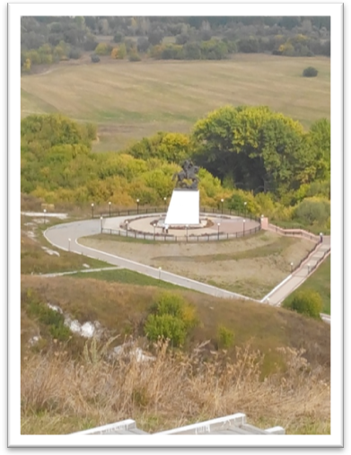
Historically it was proved that reception of Christianity was a long, preparative period, in which the main role belonged to the fact, that Svyatoslav defeated Bulgar and Khazar.
Svyatoslav decided to beat Khazar’s forces. He directed his sword against Khazar, because it was impossible to think about greatness of the country without its deliverance. The Khazars didn’t expect assault from the north. That’s why he chose his route between rivers Don and Volga. From that place he decided to attack offenders of the Rus’.
Vyatichi submitted Kiev’s prince with pleasure. Together with vyatichi’s young men Svyatoslav destroyed the capital and the whole country.
Holki’s monks were witnesses of that battle. They saw Kiev’s prince on rising horse near their caves.
Svyatoslav conquered Khazaria and united it with the northern land. There was established one of the first Russian orthodox diocese, named Belgorodskaya.
The arrival of Christianity to the northern lands, which were free from Khazar’s supremacy, was possible thanks to Svyatoslav’s victories over the Khazars. His politics, activity was send to creation of conditions for reception of Christianity.
That’ why Svyatoslav with his first victories determined the fate of orthodox Rus’. And we must honour this man, because he was the predecessor of Orthodoxy. Prince Svyatoslav raised Russian banner on inaccessible height.

